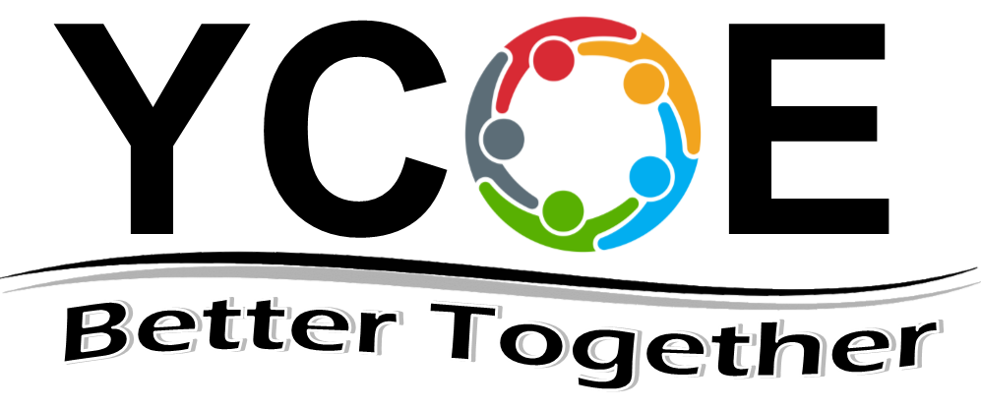
Yuba County Office of Education

Evaluation of Teaching Performance

Teacher: | Date:
School/Program:
Period covered by this evaluation: to
Dates of observations:
Status of teacher: Temporary Probationary Permanent

1 - Meets Standards 2 - Satisfactory with Recommendations 3- Unsatisfactory (Does not meet standards)

STANDARD I - Engaging and Supporting all Students in Learning | 1 | 2 | 3
- Using knowledge of students to engage them in learning
- Connecting learning to students’ prior knowledge, backgrounds, life experiences, and interests
- Connecting subject matter to meaningful, real-life contexts
- Using a variety of instructional strategies, resources, and technologies to meet students’ diverse learning needs
- Promoting critical thinking through inquiry, problem solving, and reflection
- Monitoring student learning and adjusting instruction while teaching
Comments:

STANDARD II - Creating & Maintaining Effective Environments for Student Learning | 1 | 2 | 3
- Promoting social development and responsibility within a caring community where each student is treated fairly and respectfully
- Creating physical or virtual learning environments that promote student learning, reflect diversity, and encourage constructive and productive interactions among students
- Establishing and maintaining learning environments that are physically, intellectually, and emotional safe
- Creating a rigorous learning environment with high expectations and appropriate support for all students
- Developing, communicating, and maintaining high standards for individual and group behavior
- Employing classroom routines, procedures, norms, and supports for positive behavior to ensure a climate in which all students can learn
- Using instructional time to optimize learning
Comments:

STANDARD III - Understanding & Organizing Subject Matter for Student Learning | 1 | 2 | 3
- Demonstrating knowledge of subject matter, academic content standards, and curriculum frameworks
- Applying knowledge of student development and proficiencies to ensure student understanding of subject content
- Organizing curriculum to facilitate student understanding of the subject matter
- Utilizing instructional strategies that are appropriate to the subject matter
- Using and adapting resources, technologies, and standards-aligned instructional materials, including adopted materials, to make subject matter accessible to all students
- Addressing the needs of English learners and students with special needs to provide equitable access to the content
Comments:

STANDARD IV - Planning Instruction & Designing Learning Experiences for all Students | 1 | 2 | 3
- Using knowledge of students’ academic readiness, language proficiency, cultural background, and individual development to plan instruction
- Establishing and articulating goals for student learning
- Developing and sequencing long-term and short-term instructional plans to support student learning
- Planning instruction that incorporates appropriate strategies to meet the learning needs of all students
- Adapting instructional plans and curricular materials to meet the assessed learning needs of all students
Comments:

STANDARD V - Assessing Students for Learning | 1 | 2 | 3
- Applying knowledge of the purposes, characteristics, and uses of different types of assessments
- Collecting and analyzing assessment data from a variety of sources to inform instruction
- Reviewing data, both individually and with colleagues, to monitor student learning
- Using assessment data to establish learning goals and to plan, differentiate, and modify instruction
- Involving all students in self-assessment, goal setting, and monitoring progress
- Using available technologies to assist in assessment, analysis, and communication of student learning
- Using assessment information to share timely and comprehensive feedback with students and their families
Comments:

STANDARD VI - Developing as a Professional Educator | 1 | 2 | 3
- Reflecting on teaching practice in support of student learning
- Establishing professional goals and engaging in continuous and purposeful professional growth and development
- Collaborating with colleagues and the broader professional community to support teacher and student learning
- Working with families to support student learning
- Engaging local communities in support of the instructional program
- Managing professional responsibilities to maintain motivation and commitment to all students
- Demonstrating professional responsibility, integrity, and ethical conduct
Comments:

Related Duties and Professional Responsibilities | 1 | 2 | 3
- Is punctual to class and duty assignments
- Participates in staff and committee meetings as required
- Maintains student records and submits reports as requested
- Follows county regulations and policies
- Exercises care for the health and safety of students
- Effectively utilizes an instructional aide NA
- Communicates in a professional manner
Comments:

Additional Comments/Specific Recommendations:

Overall Evaluation

Meets Standards Meets Standards with Recommendations Unsatisfactory

My signature indicates this evaluation has been discussed with me but does not necessarily indicate agreement with the content.

Evaluator’s Signature Date Teacher’s Signature Date

The employee shall be informed of his/her right to answer, explain, correct or deny, in writing, any facts in question and have his/her reply made part of their personnel file within ten (10) duty days of receiving the written evaluation. While the employee has the right to respond at any time, after the ten (10) duty days the document will be placed in the employee’s personnel file.

dl - 3/24/15

